Another attraction in Caldwell County is Grandfather Mountain. One of the things it’s known for is the “Mile High” swinging bridge near the summit of Grandfather Mountain which is shown above.

Caldwell County is also a good place for public events one of which is an annual bike ride named Bridge to Bridge. The ride starts on the Catawba River and climbs up mountains and ends climbing up the steep grade onto Grandfather Mountain.

The one problem that people usually have is; how do I get up there? Well there are two ways that people usually go. Those two ways are either take the shuttle van or drive. Most people take the shuttle van. You have to get a ticket to go. Below is an example.

Caldwell County

Researched by: Katie Rose Hand

Lenoir is Caldwell’s county seat. Below is a picture of the town square.
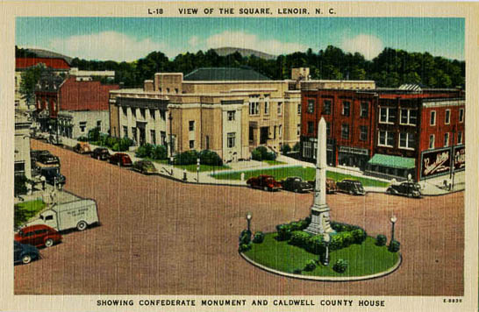

Bibliography

http://en.wikipedia.org/wiki/Caldwell_County%2C_North_Carolina

http://statelibrary.dcr.state.nc.us/NC/CNTYOUT/CNTYMAPS/COUNT2.HTM#CALDWELL

http://en.wikipedia.org/wiki/Tweetsie_Railroad

http://www.itpi.dpi.state.nc.us/counties/caldwell.html

http://www.bizjournals.com/triangle/stories/2007/01/15/daily43.html

Images

http://images.google.com/images?svnum=10&um=1&hl=en&q=Lenoir+Caldwell+County+&btnG=Search+Images

http://images.google.com/images?svnum=10&um=1&hl=en&q=Grandfather+Mountain&btnG=Search+Images

